Lab-5

Batch Code : AND-D3393
Name : Vignesh S
ID : AF05054428
Topic : SQL - DDL ( Data Definition Language )

Create a database : name can be called as EmployeeManagementSystem
mysql> create database employee_management_system;
Query OK, 1 row affected (0.01 sec)

Create a table : name can be called as Employee, Following fields or attributes [ eid, ename, emobile, eemail, ecity, salary
Database changed
mysql> create table employee (e_ID int,
-> e_name varchar(100),
-> e_mobile varchar(100),
-> e_email varchar(100),
-> e_city varchar(100),
-> salary int);
Query OK, 0 rows affected (0.08 sec)
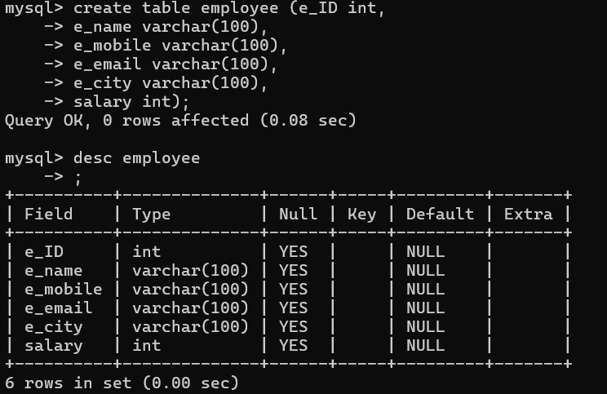

Add a new column into the existing table - employee ( estate )
mysql> alter table employee add e_state varchar(100);
Query OK, 0 rows affected (0.05 sec)
Records: 0 Duplicates: 0 Warnings: 0

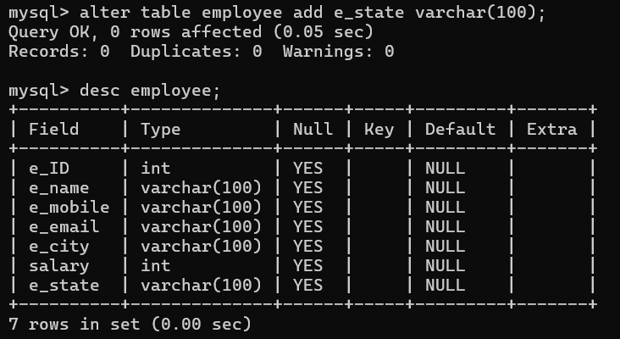
Drop a new column from the existing table - employee ( estate )
mysql> alter table employee drop column e_state;
Query OK, 0 rows affected (0.11 sec)
Records: 0 Duplicates: 0 Warnings: 0
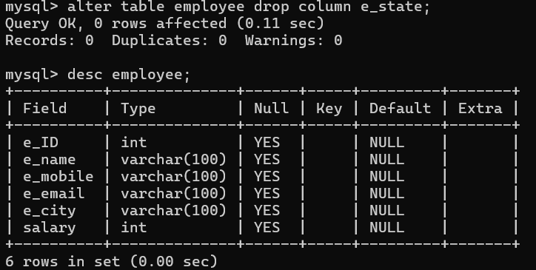

Replace a column name into the table - employee ( esalary - empsalary)
mysql> alter table employee rename column salary to emp_salary;
Query OK, 0 rows affected (0.04 sec)
Records: 0 Duplicates: 0 Warnings: 0
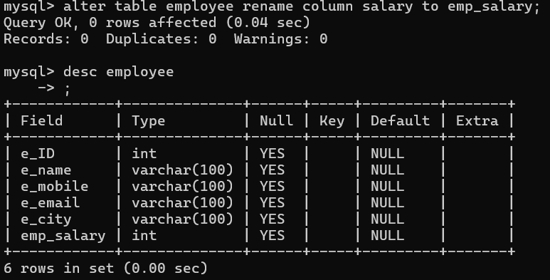
Difference between drop, delete and truncate
Command | Works on | Removes
DROP | Table or database | Full table or database
DELETE | Rows | Selected rows
TRUNCATE | Table data | All rows only

